IR FLAME SENSOR:

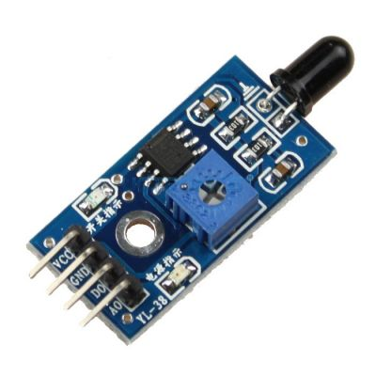

**Description:**

Flame Detection Sensor Module is sensitive to the flame, but also can detect ordinary light. Usually used as a flame alarm. Detects a flame or a light source of a wavelength in the range of 760nm-1100 nm. Detection point of about 60 degrees, particularly sensitive to the flame spectrum. Sensitivity is adjustable, stable performance.

**Features:**

* 100% brand new and high quality
* Detection angle about 60 degrees, it is sensitive to the flame spectrum.Accuracy adjustable
* Operating voltage 3.3V-5V
* Output a. analog voltage outputb. digital switch outputs (0 and 1)
* With a mounting screw holePCB size: 3cm * 1.6cm
* Power indicator (red) and digital switch output indicator (green)
* Comparator chip LM393 ,it is stable.
* Flame detection distance, lighter flame test can be triggered within 0.8m, if the intensity of flame is high , the detection distance will be increased.

**Directions:**

* + 3.3V-5V voltage
* GND
* DO -- board digital output interface (0 and 1)
* AO -- board analog output interface
* On board, digital output interface can be directly connected with the microcontroller IO.
* Please keep a distance with flame, high temperature maybe burn out the sensor module.

**Package list:**

* 1x IR Infrared Flame Detection Sensor Module Detect Fire Flame Sensor
* 4x Dupont Wires